Technical File

Document ID: TF-SG-ECL-001
Revision: Rev. 2.1
Date: July 14, 2025
Previous Revision: TF-SG-ECL-001 Rev 1.4 (07/07/2025)
Product: EclipsePro Series Solar Eclipse Glasses
Manufacturer: SIA “Gravitis Enterprise Limited"
Manufacturer Address: Lauku iela 7-4, Cēsis, LV-4101, Latvia
Regulation: (EU) 2016/425, Category II PPE
Standard: EN ISO 12312-2:2015(E)
Email: support@absoluteeclipse.com

Table of Contents
1. COVER LETTER 4
Manufacturing Sites: 4
2. PRODUCT DESCRIPTION 5
2.1 EclipsePro Paper Series 6
2.2 EclipsePro Plastic Series 7
2.3 Equivalency of Protection 7
3. DESIGN AND MANUFACTURING INFORMATION 8
3.1 Technical Drawings and Specifications 8
3.1.1 EclipsePro Paper Series 8
3.1.2 EclipsePro Plastic Series 8
3.1.3 Critical Design Requirements (Applicable to Both Series) 9
3.2 Manufacturing Process Specifications 10
3.3 Control of Optional Decorative Artwork and Branding 11
4. INSTRUCTIONS FOR USE (IFU) & MARKING STRATEGY 12
4.1 Marking & Information Location Matrix 12
4.2 Justification for Differentiated Marking Strategy 12
4.3 Instruction Documentation (Physical & Master) 13
4.4 Digital Information System (QR Code & Website) 13
4.5 Regulatory Compliance Confirmation 13
5. PRODUCT IDENTIFICATION & TRACEABILITY 14
5.1 Traceability System Specification 14
6. MATERIALS DOCUMENTATION & RISK ASSESSMENT 15
6.1 Complete Material Specifications with Test Reports 15
6.2 Essential Health and Safety Requirements (EHSR) Assessment 16
Summary of Key Risks and Control Strategies 16
Assessment Conclusion 16
6.3 Material Risk Assessment Conclusion 17
7. QUALITY CONTROL PROCEDURES 18
7.1 Enhanced Quality Control with Automated Systems 18
8. LIST OF APPLIED STANDARDS AND LEGISLATION 20
8.1 Applied Legislation and Key Harmonised Standard 20
8.2 Supporting Standards and Regulations 20
8.3 Summary of Required Information & Markings 20
9. EU DECLARATION OF CONFORMITY 21
10. RESULTS OF DESIGN CALCULATION 22
10.1 Technical Drawings 22
10.2 Material & Component Test Reports 22
10.3 Solar Filter Certification (EN ISO 12312-2:2015) 23
10.4 Regulatory & User Information Documents 23
10.5 Packaging Artwork Specification 23
10.2 Supporting Documentation Summary 24
11. DOCUMENT RETENTION COMMITMENT 25

1. COVER LETTER

Manufacturing Sites:
- Cangnan County Qiwei Craft Co., Ltd., Industrial Zone, Cangnan County, Wenzhou City, Zhejiang Province, China 325800
- SIA Gravitis Enterprise Limited, Lauku iela 7-4, Cēsis, LV-4101, Latvia

In accordance with Regulation (EU) 2016/425 Article 8(3), SIA Gravitis Enterprise Limited shall keep this technical documentation and the EU Declaration of Conformity for a period of 10 years from the date the PPE is placed on the market.

2. PRODUCT DESCRIPTION

This Technical File covers the EclipsePro Series Solar Eclipse Glasses, a form of Personal Protective Equipment (PPE) designed for the safe, direct observation of the sun.
All products described herein are Category II PPE in accordance with Regulation (EU) 2016/425 and are designed to meet all requirements of the harmonised standard EN ISO 12312-2:2015(E). The intended use for all models is to provide protection for the user's eyes against harmful solar radiation during direct viewing of a solar eclipse.
The product is offered in two distinct lines: a paper-based standard series and a plastic-based premium series.

2.1 EclipsePro Paper Series
This product line consists of solar eclipse glasses constructed from 250g/m² C1S paperboard. It serves as the standard, highly customizable model.
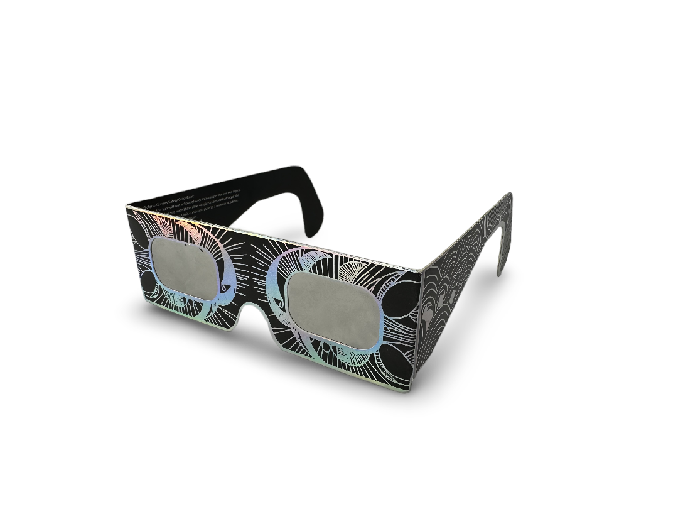
Figure 2.1: Representative base model of the EclipsePro Paper Series.
Design Variants:
The Paper Series is available in multiple fabrication variants which affect the overall dimensions and eye-opening shape, though the core protective filter remains identical. These variants are detailed in the attached technical drawing package (SEG-TDP-001-RevB.pdf) and include:
- Base Shape (Drawing: SEG-FAB-001)
- Narrow Shape (Drawing: SEG-FAB-002)
- Eye Hole Variant B (Drawing: SEG-VAR-001)
Note: The image above illustrates the fundamental construction of the Base Shape. All variants maintain full compliance with the safety requirements of EN ISO 12312-2. Cosmetic artwork applied to the frames varies but does not alter the protective structure, as detailed in Section 3.3.

2.2 EclipsePro Plastic Series
This product line is constructed from a durable, injection-molded polypropylene homopolymer. It serves as a more robust model with a fixed, standardized design, offering enhanced reusability.

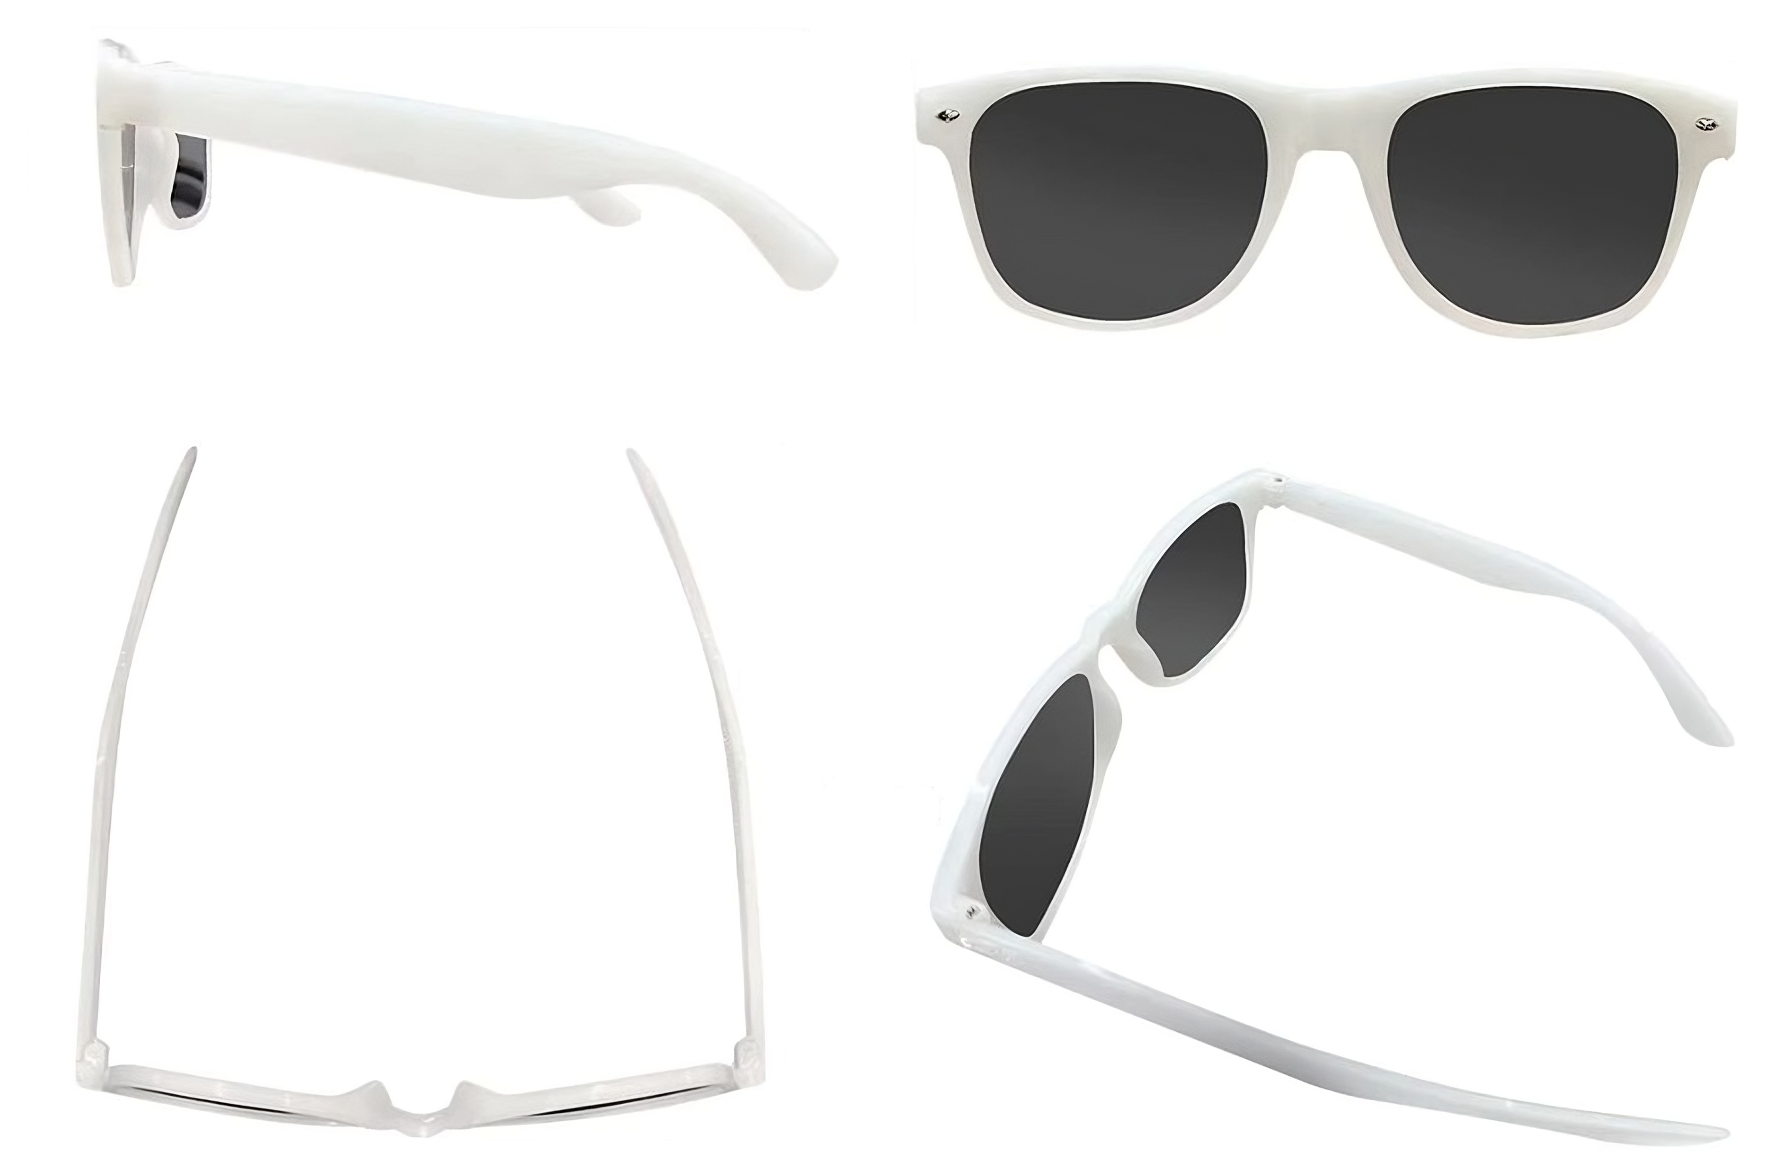
Figure 2.2: Representative model of the EclipsePro Plastic Series.
Note: The image above illustrates the fundamental construction and fixed form factor of the EclipsePro Plastic Series. It is shown without markings for illustrative clarity. Cosmetic finishes or pad-printed branding may vary but do not alter the protective structure, as detailed in Section 3.3 of this file.

2.3 Equivalency of Protection
While the models differ in frame material and durability, both the Paper Series and the Plastic Series provide the identical level of protection against harmful solar radiation. Both lines utilize independently certified solar filter and are fully compliant with all safety performance requirements of EN ISO 12312-2:2015.

3. DESIGN AND MANUFACTURING INFORMATION

3.1 Technical Drawings and Specifications
This section details the design specifications for both the EclipsePro Paper and Plastic series, as controlled by their respective technical drawing packages.

3.1.1 EclipsePro Paper Series
Document Reference: SEG-TDP-001-RevB.pdf
- Status: FOR NOTIFIED BODY SUBMISSION
- Drawing Package Contents:
  - SEG-ASSY-001: Assembly Drawing
  - SEG-MRK-001: Marking Specification
  - SEG-FAB-001: Fabrication - Base Shape
  - SEG-FAB-002: Fabrication - Narrow Shape
  - SEG-VAR-001: Fabrication - Base Shape - Eye Hole Variant B
- Key Dimensions (from Technical Drawings):
  - Overall Dimensions (Base Shape): 415mm width × 145mm height
  - Eye Opening (Standard): 40mm × 58mm
  - Eye Opening (Variant B): 38mm × 77mm
  - Frame Thickness: 250g/m² cardboard
  - Marking Dimensions: As specified in SEG-TDP-001, including a minimum 5mm height for the CE marking on packaging.
- Packaging Specifications:
  - PKG-PAPERSERIES-5PK-OUTER-001: Artwork for 5-Unit Pack Outer Carton
  - PKG-PAPERSERIES-10PK-OUTER-001: Artwork for 10-Unit Pack Outer Carton

3.1.2 EclipsePro Plastic Series
- Document Reference: SEGP-TDP-001-Rev-B.pdf
- Status: FOR NOTIFIED BODY SUBMISSION
- Drawing Package Contents:
  - SEGP-MRK-001: Marking Specification (On-Product)
  - SEGP-ASSY-001: Assembly Drawing
  - SEGP-FAB-001: Fabrication - Main Frame
- Key Dimensions (from Technical Drawings):
  - Overall Dimensions:
Total width: 140mm
Total height: 160mm (from top view)
Frame height: 49mm (front view)
  - Frame Thickness: 2.0mm (nominal)
- Packaging Specification:
  - PKG-PLASTIC-SERIES-1PK-OUTER-001: Artwork for Single Unit Primary Packaging

3.1.3 Critical Design Requirements (Applicable to Both Series)
- Filter Coverage: Minimum 3mm overlap of the solar filter around all eye openings.
- Tolerances: Linear ±0.5mm, Angular ±1°.
- Zero Light Leakage: Design ensures no light leakage around the filter edges when properly assembled.
- Filter Positioning Accuracy: Manufacturing processes ensure a maximum deviation of ±1mm.
- Structural Integrity: Design ensures structural integrity during normal handling forces.
- Complete Eye Coverage: Design ensures full bilateral eye coverage with adequate safety margins.

3.2 Manufacturing Process Specifications

Filter-Frame Bonding & Primary Assembly (Cangnan County Qiwei Craft Co., Ltd., China)
- Environmental Controls: Temperature: 20-25°C (±2°C); Humidity: 45-65% RH; Clean work environment with filtered air supply.
- Process Steps:
  - Material Receiving & Inspection: Verification of filter certificates and dimensional checks.
  - Filter-Frame Bonding: Automated lamination with precision positioning control.
  - Quality Control: 100% automated light leak and contamination inspection systems.
  - QR Code Application: Activation of the traceability system for each unit.
  - Packaging: Bulk protective packaging for secure shipment to Latvia.
Final Assembly & Packaging (SIA Gravitis Enterprise Limited, Latvia)
- Process Steps:
  - Incoming Inspection: 5% statistical sampling of components from Stage 1.
  - Final Cutting & Folding: Die press cutting and precision folding of frames per technical drawings.
  - Final Quality Control: Director-supervised physical inspection for defects and sharpness.
  - Packaging & Dispatch: Final retail packaging with all required documentation (IFU leaflet).

3.3 Control of Optional Decorative Artwork and Branding
This section defines the controlling principles for any and all decorative artwork, customer branding, or promotional markings applied to the EclipsePro Series products. These elements are distinct from and subordinate to the mandatory regulatory markings specified elsewhere in this Technical File.
The application of any such artwork is permitted only if it adheres to the following requirements:
- Positional Constraints:
  - The artwork shall be positioned so that it does not obscure, conflict with, or reduce the legibility of any mandatory regulatory markings as defined in the Marking Specification (e.g., SEG-MRK-001).
  - A non-violable clear space of at least 5mm shall be maintained around all mandatory markings.
- Material Control:
  - All materials used to apply decorative artwork must have documented evidence of compliance with the same EU safety standards as the base product materials.
  - The vegetable oil-based inks used for such artwork shall be from the set verified by SGS test reports SHAEC24022975101, ...103, ...105, and ...107, which are included in this Technical File.
  - Any other materials (e.g., alternative inks, hot stamping foils) may only be used after the manufacturer has obtained and filed complete test reports from an accredited laboratory demonstrating equivalent compliance with REACH and other applicable EU safety standards.
- Manufacturer Responsibility:
  - The legal manufacturer, SIA "GRAVITIS ENTERPRISE LIMITED," bears full responsibility for ensuring any product placed on the market, including all decorative elements, is fully compliant with these controlling principles and Regulation (EU) 2016/425.

4. INSTRUCTIONS FOR USE (IFU) & MARKING STRATEGY
This section defines the hierarchical information strategy for the EclipsePro Series, ensuring full compliance with Regulation (EU) 2016/425. The strategy provides complete and accessible information to the end-user via four distinct layers: on-product marking, on-packaging marking, a physical Instructions for Use (IFU) leaflet, and a digital platform. The approach is adapted for the unique physical characteristics of the Paper and Plastic product lines.

4.1 Marking & Information Location Matrix
The physical IFU leaflet serves as the primary, comprehensive guide for the user, repeating and explaining information found elsewhere.
Information / Marking | EclipsePro Paper Series (Location) | EclipsePro Plastic Series (Location)
CE Mark & Notified Body Nr. | On-Product & IFU Leaflet | On-Product & IFU Leaflet
Standard (EN ISO 12312-2) | On-Product & IFU Leaflet | On-Product & IFU Leaflet
Manufacturer Name & Address | On-Product & On-Packaging & IFU Leaflet | On-Packaging & IFU Leaflet
Product Model Identification | On-Product & On-Packaging & IFU Leaflet | On-Packaging & IFU Leaflet
EU Type-Examination Statement | On-Product & On-Packaging | On-Packaging
QR Code & Unique Serial Number | On-Product | On-Packaging
Use By Date | Provided Digitally (via QR/Serial) | Provided Digitally (via QR/Serial)
Storage Conditions | IFU Leaflet Only | IFU Leaflet Only
Governing Artwork Document | PKG-PAPERSERIES-5PK-OUTER-001  PKG-PAPERSERIES-10PK-OUTER-001 | PKG-PLASTIC-SERIES-1PK-OUTER-001

4.2 Justification for Differentiated Marking Strategy
The variation in marking locations between the Paper and Plastic series is a necessary adaptation due to fundamental differences in their physical construction.
- Justification: The temple arms of the injection-molded EclipsePro Plastic Series are significantly narrower and feature a continuous curved profile. This geometry makes it technically infeasible to legibly and permanently print extensive text (such as the full manufacturer address or the EU Type-Examination statement) while meeting the minimum character height and clarity requirements of the regulation.
- Contrast: The EclipsePro Paper Series is constructed from flat, wide paperboard, which provides ample surface area for the application of all mandatory markings directly onto the product.
- Conclusion: In accordance with the provisions of Regulation (EU) 2016/425 for space-constrained products, the non-essential markings for the Plastic Series are moved to the primary packaging and accompanying leaflet.

4.3 Instruction Documentation (Physical & Master)
To ensure all users have access to critical safety information, instructions are provided in multiple formats.
Physical Instructions for Use (IFU): Every retail unit includes a printed leaflet with comprehensive safety warnings, usage instructions, and storage conditions.
  - Languages: English, German, French, Italian, Spanish, Portuguese, and Dutch.
  - Document Control: For full traceability, each leaflet is printed with its unique document number, revision, and release date (July 13, 2025). The document identifiers correspond to the product series:
    - Leaflet for EclipsePro Paper Series: SEG-IFU-Physical-001-Rev-B
    - Leaflet for EclipsePro Plastic Series: SEGP-IFU-Physical-001-Rev-B
Digital Instructions for Use (IFU): The complete and most up-to-date version of the instructions is always digitally available online.

4.4 Digital Information System (QR Code & Website)
The traceability and shelf-life information system is entirely digital.
- Access: Each unit is assigned a unique serial number, accessible via a scannable QR code and as a human-readable number. Users can access product-specific data by scanning the code or by manually entering the serial number at verify.absoluteeclipse.com.
- Information Provided: The system provides the product’s official Use By date, its manufacturing date, and a link to the complete digital IFU and EU Declaration of Conformity (DoC). This system is detailed in Section 5.1.

4.5 Regulatory Compliance Confirmation
This multi-layered information strategy ensures full compliance with Regulation (EU) 2016/425, Article 8, and Annex II. The justified, differentiated approach for the EclipsePro Plastic Series guarantees that all mandatory information remains clear, accessible, and permanently available to the end-user throughout the product's lifecycle.

5. PRODUCT IDENTIFICATION & TRACEABILITY

5.1 Traceability System Specification
Identification Method: Per-Unit Serial Number
Example: 9005585
The traceability system is based on a unique serial number assigned to every individual unit, replacing traditional batch marking. This serial number is accessible as both a scannable QR code and a human-readable number. Users can access the product's unique information by either scanning the QR code or by manually entering the serial number at verify.absoluteeclipse.com.

QR Code and Serial Number Location:
- EclipsePro Paper Series: The unique QR code and serial number are applied directly to each individual product frame.
- EclipsePro Plastic Series: Due to on-product space constraints, the unique QR code and serial number are applied to the primary retail packaging.

Each unique serial number provides access to a digital record containing:
- Manufacturing Date and the official Use By Date.
- Product model variant identification.
- Link to the complete digital Instructions for Use (IFU) and EU Declaration of Conformity (DoC).
- Verification of key quality control checks.
- Company contact information for compliance documentation.
- Material traceability reference numbers.

Traceability Chain:
The system creates a verifiable link from raw material supplier batches through internal production records to the unique serial number assigned to each finished product. This complete chain is stored digitally for the required 10-year retention period.
This system ensures individual product traceability and satisfies the information and traceability requirements of Regulation (EU) 2016/425 Article 8(5).

6. MATERIALS DOCUMENTATION & RISK ASSESSMENT

6.1 Complete Material Specifications with Test Reports
All materials used in the EclipsePro Series solar eclipse glasses have been selected for innocuousness and are verified for compliance with applicable EU safety regulations through test reports from internationally accredited laboratories.
A complete and detailed matrix of all materials, their specifications, manufacturers/suppliers, and corresponding compliance test reports is provided in the following controlled document:
TF-SG-ECL-001-AnnexB: Material Compliance Summary
This annex serves as the primary reference for all material compliance evidence and supersedes the detailed lists previously in this section.

Note on Test Report Naming and Scope: The solar filter material is identical across all product variants. The test reports from ICS Laboratories (series T18671) confirm its compliance. Some reports may refer to internal development product names (e.g., "Absolute Eclipse Glow in the Dark Solar Glasses"); however, they document the testing of the final, certified filter component used in all EclipsePro Series models. The phosphorescent pigment used for the "glow" effect in the plastic series is a purely cosmetic additive and has been independently verified for safety and innocuousness.

6.2 Essential Health and Safety Requirements (EHSR) Assessment
In accordance with Annex II of Regulation (EU) 2016/425, a comprehensive and systematic risk assessment has been conducted to identify all relevant hazards for the EclipsePro Series Solar Eclipse Glasses. The harmonised standard EN ISO 12312-2:2015 has been used to presume conformity with the relevant EHSRs it covers.
The complete, detailed analysis demonstrating compliance with each applicable requirement is documented in the formal checklist attached to this Technical File:
Primary Record: Annex A: Essential Health and Safety Requirements (EHSR) & Risk Assessment Checklist (Document ID: TF-SG-ECL-001-AnnexA)
This Annex serves as the definitive record of the EHSR assessment.

Summary of Key Risks and Control Strategies
The assessment confirmed that the primary risks associated with this type of PPE have been fully addressed through a multi-layered control strategy:
- Hazard: Non-ionising Solar Radiation.
  - Control: Use of a specialized polymer solar filter, certified by an accredited laboratory (ICS Laboratories) to meet all spectral transmittance requirements of EN ISO 12312-2:2015.
- Hazard: Chemical Hazards from Materials.
  - Control: All constituent materials (polypropylene frame, paperboard frame, inks, foils, adhesive) have been selected for innocuousness and their compliance verified against EU regulations (e.g., REACH SVHC) through test reports from accredited laboratories (SGS, Sinolight).
- Hazard: Light Leakage and Physical Integrity.
  - Control: Robust frame designs that ensure full eye coverage and a minimum 3mm filter overlap are documented in technical drawings. Risks are further mitigated by automated manufacturing controls (e.g., 100% light leak inspection) and final quality control procedures.
- Hazard: Misuse and Lack of Information.
  - Control: Provision of clear, permanent on-product markings and a comprehensive, multi-language printed Instructions for Use (IFU) leaflet with every unit, as detailed in Section 4 of this Technical File.

Assessment Conclusion
All applicable Essential Health and Safety Requirements of Annex II are satisfied through the combination of compliant design, verified materials, controlled manufacturing processes, and comprehensive user information. All identified risks have been reduced to an acceptable level, ensuring the product is safe for its intended use.

6.3 Material Risk Assessment Conclusion
Complete Material Compliance Matrix:

Material / Component | Governing Evidence (Test Report ID) | Verified Standard / Regulation | Status
Solar Filter Film | T18671-01-5 & T18671-01-7 (ICS Labs) | EN ISO 12312-2:2015 | ✅ PASS
Paper Frame | 2025020014 (Sinolight) | GB/T 24999-2018 | ✅ PASS
Plastic Frame (Base Resin) | Formosa Product Safety Certificate | REACH SVHC | ✅ PASS
Plastic Frame Additive (Glow Powder) | RT20250430004 (DGRTTS MSDS) | GHS Chemical Safety | ✅ PASS
Printing Inks (CMYK) | SHAEC24022975101 / 103 / 105 / 107 (SGS) | EU Chemical Safety (Mineral Oil) | ✅ PASS
Adhesive | CANEC25014912901 (SGS) | REACH SVHC | ✅ PASS
Hot Stamping Foil | TAOEC25006916401 (SGS) | REACH Phthalates | ✅ PASS

Risk Assessment Conclusion: All materials used in the EclipsePro Series have been tested by internationally accredited laboratories (SGS, Sinolight, ICS). The results confirm full compliance with the relevant Essential Health and Safety Requirements of Regulation (EU) 2016/425, primarily Regulation (EC) No 1907/2006 (REACH) for chemical safety and EN ISO 12312-2:2015 for the solar filter's performance and material innocuousness.

7. QUALITY CONTROL PROCEDURES

7.1 Enhanced Quality Control with Automated Systems
China Manufacturing - Automated Quality Control:
1. Position Control System:
- Automatic lamination machine with precision film positioning
- Tolerance: ±1mm maximum deviation
- Action: Machine stops when tolerance exceeded
- Resolution: Operator repositioning required before restart
2. Contamination Detection System:
- Automated inspection of frame surface cleanliness before filter application
- Action: Machine stops when contamination detected
- Protocol: Cleaning required before production continues
3. Light Leak Detection System:
- Coverage: 100% automated inspection of each completed unit
- Tolerance: 0% light transmission (complete seal required)
- Action: Automatic rejection and segregation of defective units
Statistical Quality Sampling:
- Frequency: 5% of production with minimum 10 units per batch
- Inspection Checklist:
  - Filter integrity (no scratches, holes, or delamination)
  - Frame condition (no cracks or structural damage)
  - Bond quality (no separation or air bubbles)
  - Markings present and legible
  - QR code scannable and functional
Pass/Fail Criteria:
- PASS: All automated systems confirm compliance, visual inspection confirms no safety-affecting defects
- FAIL: Any automated system failure or visual defect affecting safety = batch investigation
- Critical Defect: Any filter damage = immediate batch hold and root cause analysis
Latvia Final Assembly Quality Control:
- Incoming Inspection: 5% sampling of China-manufactured components
- Process Control: Die press maintenance, operator certification, director oversight
- Final Approval: Director sign-off based on 3 solar eclipse campaigns experience
- Documentation: Digital records linked to QR traceability, 10-year retention

8. LIST OF APPLIED STANDARDS AND LEGISLATION

8.1 Applied Legislation and Key Harmonised Standard
- Regulation (EU) 2016/425: on Personal Protective Equipment (PPE).
- EN ISO 12312-2:2015(E): Eye and face protection - ... Filters for direct observation of the sun. Compliance with this harmonised standard provides presumption of conformity.

8.2 Supporting Standards and Regulations
- REACH Regulation (EC) 1907/2006: Registration, Evaluation, Authorisation and Restriction of Chemicals (Applied for SVHC screening).
- GB/T 24999-2018: Coating paper and board (Applied to the Paper Series frame).

8.3 Summary of Required Information & Markings
This list summarises the key information and markings applied across the product system. The exact location is defined in Section 4.1.
- CE Mark
- Notified Body Identification (Provided on packaging/IFU, not adjacent to CE mark)
- EN ISO 12312-2 standard identification
- Manufacturer & Product Identification
- Category II PPE classification
- Unique Product Identification (Per-unit QR code/serial number)
- Use By Date (Provided digitally via the QR code system)

9. EU DECLARATION OF CONFORMITY
Status: Prepared and ready for finalization upon successful certification
(DOC-SG-ECL-001)
Availability: Will be accessible via:
- QR code scan on each product
- Website: verify.absoluteeclipse.com
- Email request: support@absoluteeclipse.com
- Content: Declaration confirming compliance with Regulation (EU) 2016/425 and EN ISO 12312-2:2015(E)

10. RESULTS OF DESIGN CALCULATION

10.1 Technical Drawings
- EclipsePro Paper Series:
  - SEG-TDP-001 Rev. B - Complete Technical Drawing Package (7 sheets)
- EclipsePro Plastic Series:
  - SEGP-TDP-001 Rev. B – Complete Technical Drawing Package (5 sheets)

10.2 Material & Component Test Reports
A complete matrix of all constituent materials, their specifications, suppliers, and corresponding compliance test reports is consolidated in the following controlled document:
- TF-SG-E-001-AnnexB: Material Compliance Summary
This annex serves as the master list for all material-related compliance documentation and contains the full details for the frame, inks, foils, adhesives, and additives.

10.3 Solar Filter Certification (EN ISO 12312-2:2015)
The solar filter film used in all product variants is certified for compliance with EN ISO 12312-2:2015.
- T18671-01-1 - Solar Filter Compliance Test Report (ICS Laboratories)
- T18671-01-3 - Solar Filter Compliance Test Report (ICS Laboratories)

10.4 Regulatory & User Information Documents
- Instructions for Use (Paper Series):
  - SEG-IFU-Physical-001 Rev. B - Printed Instructions of Use Leaflet
- Instructions for Use (Plastic Series):
  - SEGP-IFU-Physical-001 Rev. B – Printed Instructions of Use Leaflet
- EU Declaration of Conformity:
  - DOC-SG-ECL-001-RevA - EU Declaration of Conformity

10.5 Packaging Artwork Specification
- PKG-PAPERSERIES-5PK-OUTER-001 Rev. A: Outer Carton Artwork (5-Pack)
- PKG-PAPERSERIES-10PK-OUTER-001 Rev. A: Outer Carton Artwork (10-Pack)
- PKG-PLASTIC-SERIES-1PK-OUTER-001 Rev. A: Primary Packaging Artwork (Plastic Series)

10.6 Supporting Documentation Summary
The complete documentation package demonstrates full regulatory compliance through:
- Technical drawing specifications with dimensional tolerances
- International laboratory testing of all materials
- Comprehensive quality control procedures
- Full traceability and marking systems
- EU regulatory compliance verification

11. DOCUMENT RETENTION COMMITMENT
In accordance with Regulation (EU) 2016/425 Article 8(3):
SIA Gravitis Enterprise Limited commits to keeping this technical documentation and the EU Declaration of Conformity for a period of 10 years from the date the PPE is placed on the market. This includes:
- Complete technical file and all revisions
- All supporting test reports and material certifications
- Quality control records and traceability documentation
- Manufacturing process specifications and drawings
- Declaration of Conformity and certification documentation
Document Control:

Person Responsible for Technical Documentation:
Māris Grvitis, Director
SIA Gravitis Enterprise Limited

Approved by: Māris Gravitis, Director
Date: July 14, 2025
Signature:
Notified Body: MTIC Intercert S.r.l. 0068, Via G. Leopardi. 14 - 20123 Milan (MI) – Italy

END OF TECHNICAL FILE Rev. 2.1

